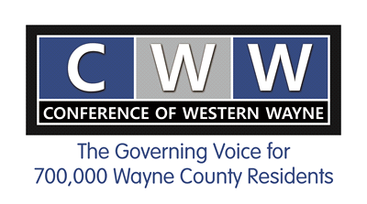
Conference of Western Wayne
Board Meeting Schedule
2017

January 13 City of Northville
February 10 Romulus (CWW/DCC pre-meeting mixer)
March 10 Comcast
April 21* City of Inkster
May 12 City of Livonia
June 9 City of Dearborn
July No meeting
August No meeting
September 8 City of Westland
October No meeting
November 3* Northville Township
December 8 City of Plymouth
*The April meeting has been moved to the 3rd week in April due to the Good Friday holiday. The November meeting has been moved to the first week in November due to the Veterans Day holiday.
*Dates switched
Revised 02/28/17

